Foundations of Algebra
Grade Level: Sixth

Stephanie J. Olson
solson@frontier.com
Bemidji State University

Mathematical Foundations of Algebra for Teachers
Math 5065
Bemidji State University
Todd Frauenholtz | tfrauenholtz@bemidjistate.edu

July 24, 2017

Table of Contents

Executive Summary……………………………………………………………………………………………. 3-4
Introduction to Algebra……………………………………………………………………………………… 5
Find the Number Variables………………………………………………………………………………… 5-7
Variable Video……………………………………………………………………………………….. 5
Balance the Scale……………………………………………………………………………………………….. 8

X Finds Out His Value Video……………………………………………………………………. 8
Activity 1 Keep Your Balance………………………………………………………………..... 8
Algebra Tiles…………………………………………………………………………………………………….... 9
Algebra Tile Distributive Property Video………………………………………………… 9
Activity 2-7 Making Equations………………………………………………………………… 10-17
Algeblocks………………………………………………………………………………………………………….. 18
Algeblocks Promote Algebraic Learning by Ferdinand D. Rivera……………. 18-20
Activity 1 Introduction to Algeblocks……………………………………………………… 20-22
Activity 2 Introduction to Algeblocks continued…………………………………….. 22-23

References………………………………………………………………………………………………………….. 24

Executive Summary

This unit was developed to meet the following Minnesota State Math Standard(s):
Strand 6: Algebra
Standard: Determine whether an equation or inequality involving a variable is true or false for a given value of the variable.
Numbers &
Benchmark: 6.2.1.1
Understand that a variable can be used to represent a quantity that can change, often in relationship to another changing quantity. Use variables in various contexts.
6.2.3.2
Solve equations involving positive rational numbers using number sense, properties of arithmetic and the idea of maintaining equality on both sides of the equation. Interpret a solution in the original context and assess the reasonableness of results.
Core: 6.EE.A.2c
Evaluate expressions at specific values of their variables. Include expressions that arise from formulas used in real-world problems. Perform arithmetic operations, including those involving whole-number exponents, in the conventional order when there are no parentheses to specify a particular order (Order of Operations).

6.EE.A.3
Apply the properties of operations to generate equivalent expressions. For example, apply the distributive property to the expression 24x + 18y to produce the equivalent expression 6(4x + 3y); apply properties of operations y + y + y to produce the equivalent expression 3y.
The target audience is fifth grade students. Given the complexity of some of the concepts, there are sections of this unit that will require more than one class period of instruction and learning.
Students will learn about algebra equations and how to solve them using the concept that the equation is “balanced”. Videos, algebra tiles, and algeblocks will be used to introduce variables and practice how to solve equations using these manipulatives. Students will have the opportunity to complete several algebra exercises independently and with a partner.
After completing this unit, students will be able to successfully answer questions for the Minnesota Comprehensive Assessment (MCA). Examples of these questions include:

Solve for X: 3x + 2x = x + 8
Solve the equation using algeblocks: (-x + 7)(x + - 1)
Assessments:
- Students will analyze the interaction within and among quantities and variables. They will be able to use appropriate representations, including tables, words, algebraic expressions and explicit equations as they explain their answers orally and on a written test.
- Students will represent and solve problem situations that involve variable quantities and be able to use appropriate manipulatives or computers, as they make oral presentations explaining their approaches and solution strategies.
Once the unit is complete, a review of algebra concepts will take place and students will practice solving equations using manipulatives. A pre-assessment will be administered and based on these results; any concepts causing difficulty for the students will be reviewed and reassessed.
If you already know simple arithmetic, you are ready to begin with the introduction to algebra. The basic idea is there is an equation - where both sides are actually the same; think of both sides as “balanced”.
Picture a scale with the same values on each side and a basic understanding of algebra is conceived.
Let’s begin: Take a simple equation:
6 = 6

Use simple arithmetic operations to change the equation yet keep it balanced:
2 + 4 = 6 or 6 = 3 $×$ 2
Thus: 2 + 4 = 3 $×$ 2

In past grades, you were shown a problem sentence where you filled in the square with the answer that made the solution correct. Example:
2 + = 6

An equation can be written similarly:
2 + 4 = $×$ 2

In simple arithmetic, we would know to place a 3 in the box. But we are ready for basic algebra and a term known as a variable.

VARIABLE https://www.youtube.com/watch?v=hK_LQaNDxi4

We will use the letter ‘x’ as the variable. Variables are defined as numbers that can change value or represent a missing value (an unknown value). Variables are usually represented by letters of the alphabet and the letters x, y, and z are most commonly used. You may ask, if we know the answer is 3 to the equation, why are we using a letter? Well, that’s the way algebra is—the meaning of ‘why’ is not always straight forward.
Now we need to solve for the variable ‘x’ in our basic algebra equation and we know: x = 3
2 + 4 = $×$ 2
x

Why is the letter x used? Because it is easier to write ‘x’ than drawing an empty square with each equation. Also, if more than one variable is used, a different letter can take its place. The squares would all look alike.

EXERCISE 1:
Solve the equations for variable x.

- 12 $–$ 8 = 1 + x 2. 7 $×$ x = 7 + 7 3. x + 3 = 6 + 6 4. 5 $- 3$= x $÷$ 4

How to Solve an Equation with a Variable
The equation x $–$ 6 = 3 can be solved in a step by step approach:
- Work out what to remove to get x alone
- Remove it by doing the opposite (adding is the opposite of subtracting)
- Do that to both side
We need to add 6 on both sides of the equation: x $–$ 6 + 6 = 3 + 6 x both = 9
EXERCISE 2: Find the Numbers
Below you see four triangles with missing numbers. This exercise will help understand the use of variables.
Note…the first two triangles only one answer is possible.
The third triangle, many different answers are possible. See how many you can find. The fourth is trickier.

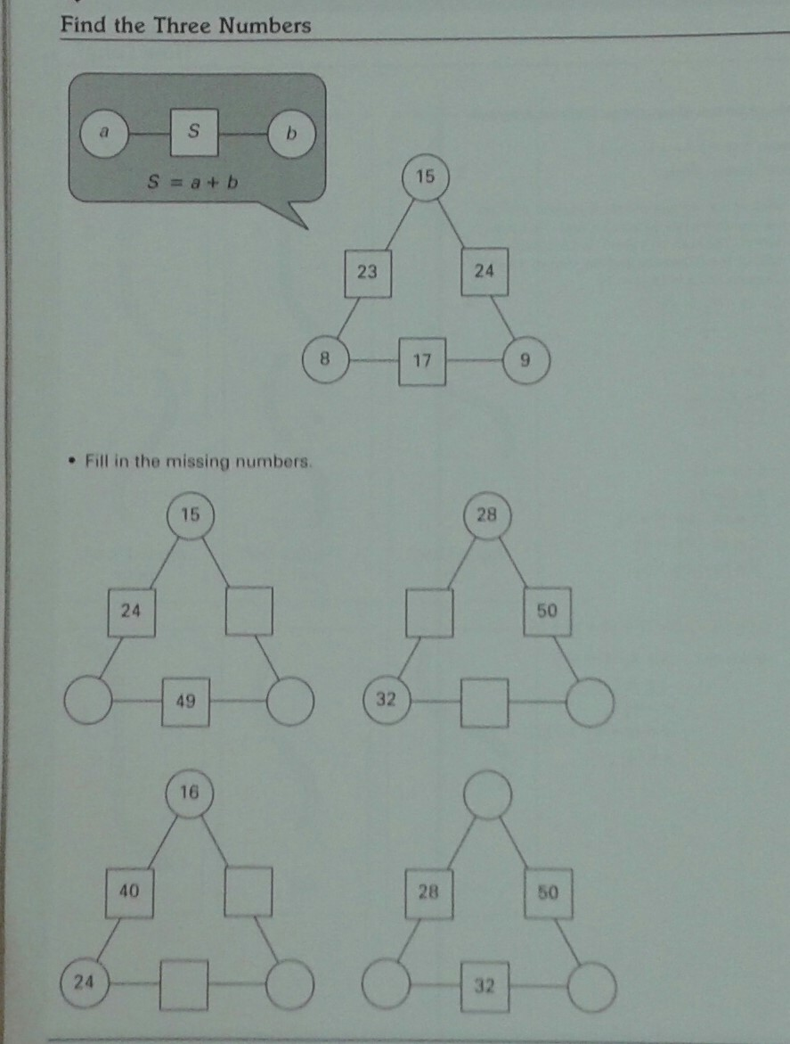
THE BALANCE SCALE

X Finds Out His Value https://www.youtube.com/watch?v=J2TYyUftI8k
It was stated earlier there is an equation where both sides are actually the same; think of both sides as “balanced”.
Let’s demonstrate this with a balance. I will model an equation on the balance scale. To find the value of the variable that makes the equation true, isolate the variable by performing the same operations to both sides of the balance. The
solution to the equation is the value of the side when the opposite side has just a single variable. To solve using division, evenly distribute the pan contents into a number of groups equal to the divisor and then delete the contents of all but one group.

One Solution, No Solutions, Infinite Solutions
An equation that simplifies to the form x = a has exactly one solution. An equation that simplifies to the form
a = a has an infinite number of solutions because any value of x will balance the scales and make the equation true. An equation that simplifies to the form a = b (where a and b are different constants) has no solutions because there is no value of x that will balance the scale and make the equation true.

3 + 2 = 6? Oops! 4 + 2 = 6? Woohoo!
x + 2____________ 6__

What number can we put for x that will keep the scale balanced?

ACTIVITY 1: Using your balance scale, solve for x. Rewrite the equation with your answers.
- x – 4 = -9 2. x – 2 = 7 3. x + 3 = -8
4. 3x + 2x = x + 8 5. 2x + 3 = 2x - 5 6. 2x + 6 = -x

ALGEBRA TILES
Another way of using manipulatives for solving equations with variables are Algebra Tiles. Algebra Tiles provide concrete models of variables and integers that enable students to explore and better comprehend basic algebraic concepts. I will introduce the concept and students will then practice the concept.
Algebra Tiles are not used for solving problems. They serve as models to bridge the gap between a concept and the symbols used to record it algebraically.
Let’s begin with the basics and watch a short one minute video on Algebra Tile Distributive Property Video

Ccc = x

= 1 (a unit)

Using the Algebra Tiles, show the equation $2x + 3$

We know x = one green rectangle tile and 1 (a unit) or a hexagon tile.

We have 2 green rectangle tiles representing x and 3 blue hexagons representing 1 (a unit).
We can now read this as: $2 x + 3$
How would we demonstrate: $3x+ 2$

ACTIVITY 2
Working in pairs, use your Algebra Tiles to show your partner the following equations:
- $x + 4$ 2. $2x + 2$ 3. $3x+4$ 4.$x+3$
__________________________________________________________________
If you and your partner both have $x+2$ and you added them together, would it look something like this:

Now you each have an $x+2$
$x + 2$ $x + 2$
We can rewrite that as (x + 2) + (x + 2)
2x + 4
2(x + 2)
You and your partner have 1x + 1x and 1 unit + 1 unit + 1 unit + 1 unit
Add your x’s.
Add your units.
Then factor.
ACTIVITY 3
Working again in pairs, use your Algebra Tiles and show the adding together of the following equations:
Write an equation for each using the above example. Simplify and factor.
1. $x + 4$ 2. $2x + 2$ 3. $3x+4$ 4.$x+3$
___________________________________________________________________
NEGATIVES
The underside of the tiles are black. Black will represent negative.

$= -x$

$= -1$ (a negative unit)

________________________________________________________________________________________________
Let’s show $2x -3$

What about $-2x + 3$

__________________________________________________________________________________________________
ACTIVITY 4
Working in pairs, use your Algebra Tiles to show your partner the following equations:

1. $x - 4$ 2. $-2x - 2$ 3. $3x-4$ 4.$-x+3$
If you and your partner both have $-x+2$ and you added them together, would it look something like this:

$-x + 2$ $-x + 2$

We can rewrite that as $(-x + 2) + (-x + 2)$
$-2x + 4$
$$-2(x - 2)$$
You and your partner have 1 -x + 1 -x and 1 unit + 1 unit + 1 unit + 1 unit
Add your x’s.
Add your units.
Then factor.
_________________________________________________________________________________________________
ACTIVITY 5
Working again in pairs, use your Algebra Tiles and show the adding together of the following equations:
Write an equation for each using the above example. Simplify and factor.
1. $x- 4$ 2. $-2x- 2$ 3. $3x-4$ 4.$-x+3$

The x², xy, y²
We are now going to include three more tiles to our activities. Note—Algebra Tiles are not proportional like other math manipulative. One variable is not necessarily a multiple of the other—the x² tiles cannot be exactly covered by xy tiles and an xy tile cannot be covered by y² tile.

= x²

= xy

= y²
___________________________________________________________________________________________

Example: 3x²

___________________________________________________________________
Example: 2xy
_______________________________________________________________________________________________________________________________________
Example: 4y²
___________________________________________________________________________________
An EXAMPLE of 2x² + xy + 2y² would be:

ACTIVITY 6
Working in pairs, use your Algebra Tiles to show your partner the following equations:

- 3x² + 2xy + 4y² 2. x² + 3xy + y² 3. 2x² + 4xy + 3y² 4. X² + xy + 5y²
___________________________________________________________________
An EXAMPLE of 2x² - xy - 2y² would be:

__________________________________________________________________________________________________

ACTIVITY 7
Working in pairs, use your Algebra Tiles to show your partner the following equations:

- 3x² - 2xy + 4y² 2. x² + 3xy - y² 3. -x² + 4xy + 3y² 4. x² - xy + -5y²
___________________________________________________________________

Algebra Tiles Worksheet 1
Complete the worksheet with the use of your Algebra Tiles.
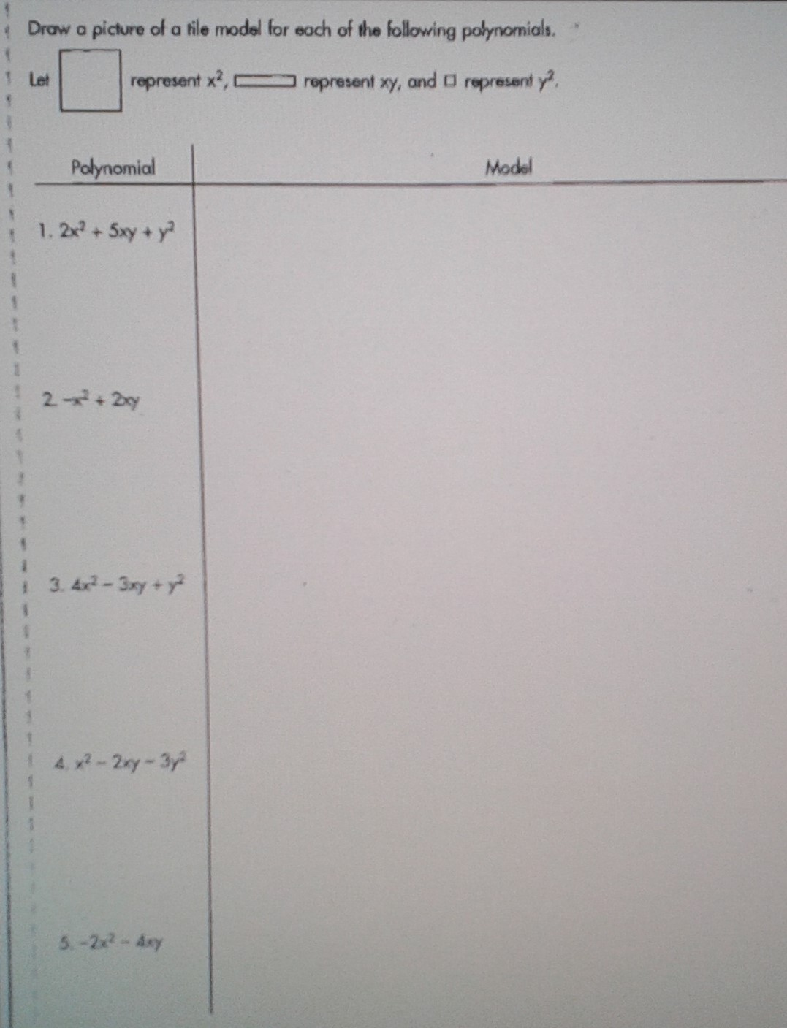
Algebra Tiles Worksheet 2
Write the equation for each of the algebra tiles model.

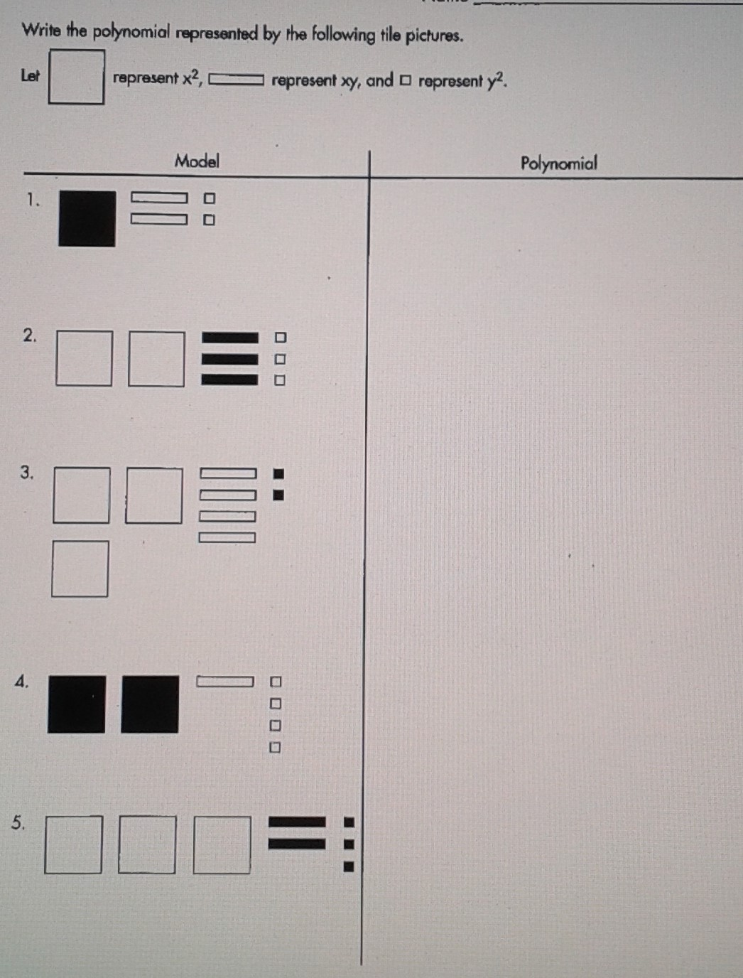
ALGEBLOCKS

Algeblocks Promote Algebraic Learning by Ferdinand D. Rivera
https://www.hand2mind.com/pdf/algeblocks/algeblocks-whitepaper.pdf

Similar to Algebra Tiles, Algeblocks have the same concept: they are manipulatives to teach anything from counting, to whole number, integer and basic operations on simple algebraic expressions (even quadratics and polynomials, and solving equations. It is a tool to think with and to help students make sense of the mathematics they often encounter through abstract presentations.
Whether you use Algeblocks or Algebra Tiles, students use a unit, x and x² manipulatives, along with an addition/subtraction mat, equations mat, or multiplication/division mat. Unlike Algebra Tiles, Algeblocks ARE proportional. One variable is a multiple of the other—the x² blocks can be covered by xy blocks and an xy block can be covered by y² .

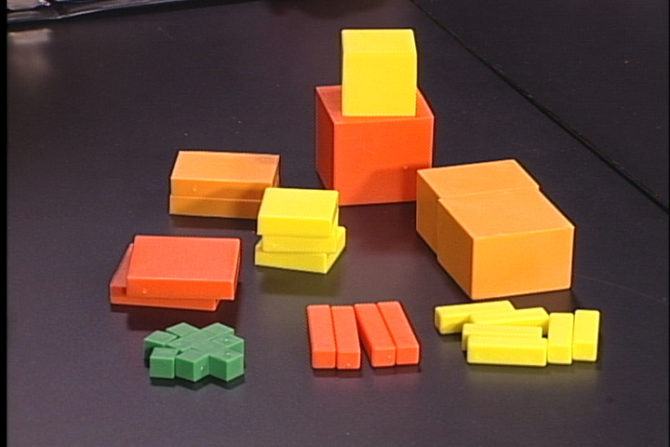
ALGEBLOCKS

x = yellow rectangles
x² = yellow squares
x³ = yellow cube
y = orange rectangles
y² = orange square
y³ = orange cube
xy = tangerine rectangles
xy² = tangerine blocks
units = green small cubes

To learn how to use the quadrant mat, we will watch this short video.

Algeblocks - Quadrant Mat
https://www.youtube.com/watch?v=G1NHdx6capE

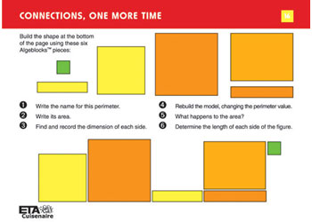
This photo shows how nicely the
Algeblocks ARE proportional.
One variable is a multiple of the other—the x² blocks can be covered by xy blocks and an xy block can be covered by y² .

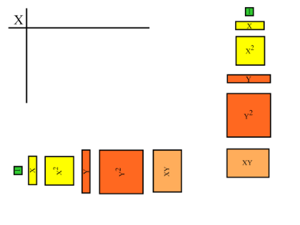
These photos show the Algeblocks’ different sizes, colors and values.
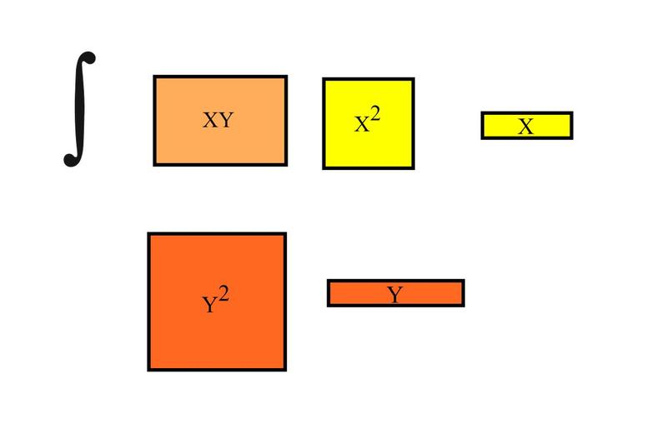

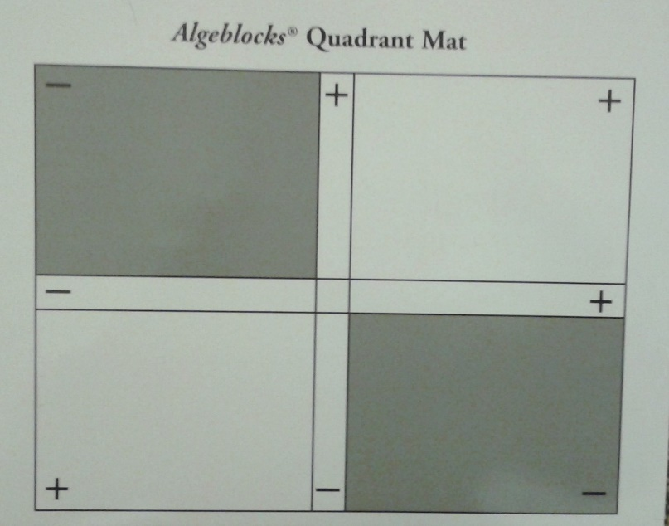
Algeblocks Quadrant Mat has positive and negative (plus and minus) labeled in its quadrant corners. The middle + is the neutral factoring zone you will be using to solve your equations.

ACTIVITY 1: What would (x + 3)(x +2) look like on the Algeblocks Quadrant mat?

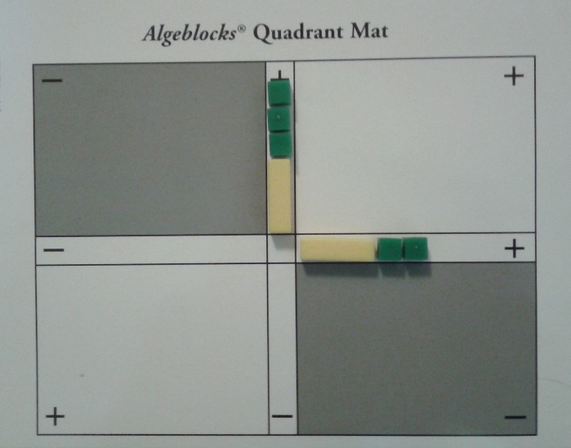
Yellow = x
Green = units or ones
The (x + 3) is in the vertical factoring axis where positive is at the top and negative at the bottom.
(x + 2) is in the horizontal factoring axis where positive is at the right and negative at the left.

Let’s solve this equation.

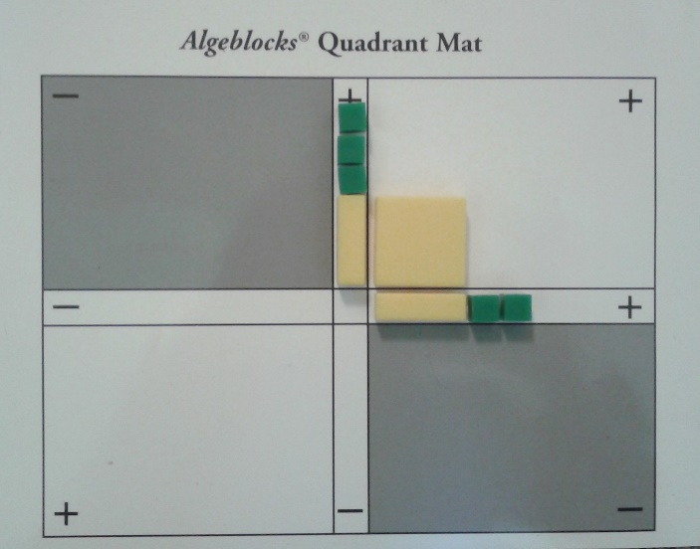
Beginning in the vertical axis and going clockwise, multiply x to the horizontal x to get x². We are multiplying a positive with a positive so our answer goes into the + quadrant.

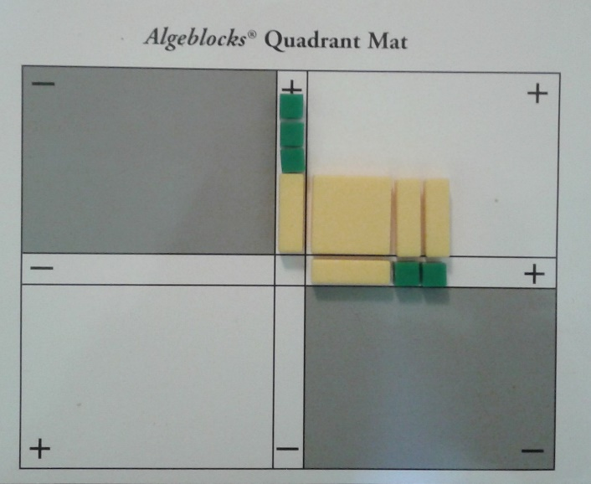
Working the vertical x across the horizontal axis, multiply x by the next two units to give x + x or 2x

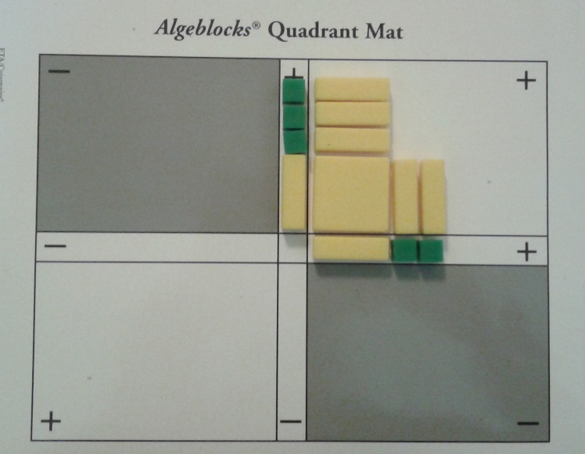
We have completed the vertical x multiplication. Working up the vertical axis multiply each unit by the horizontal x to get
x + x + x to give 3x

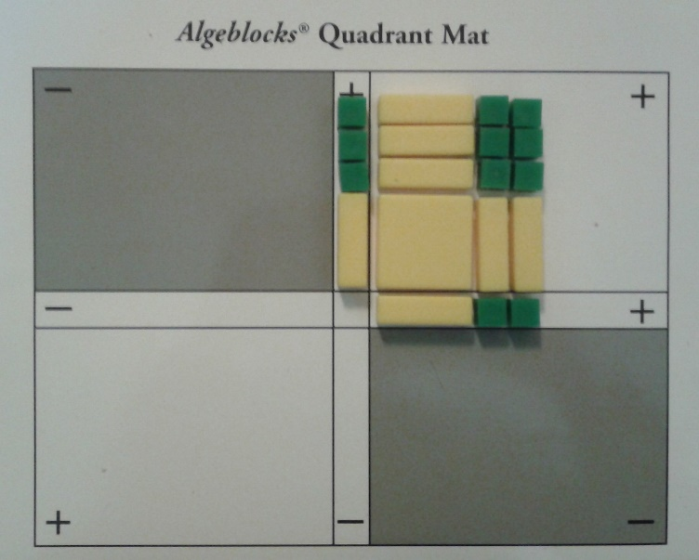
Now multiply the units on the vertical axis with the horizontal to get 6 units.

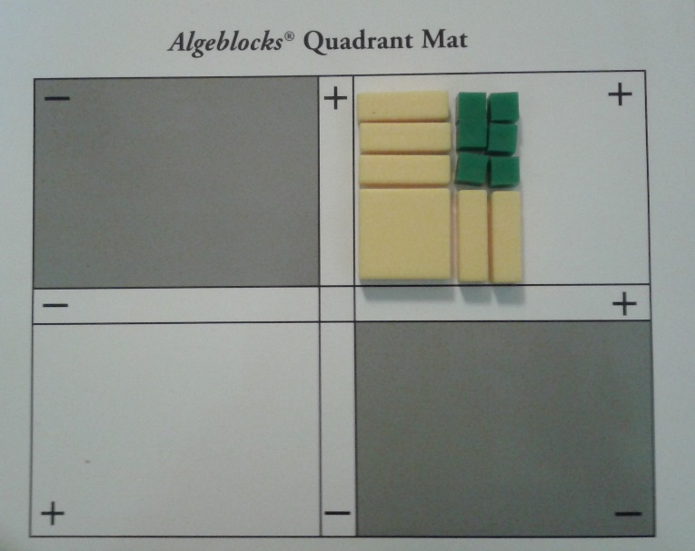
Notice the shape of your answer. When done correctly a square will form.
Count the number of x² , the number of x s and the units.

Remove your working equation from the factoring axis’.

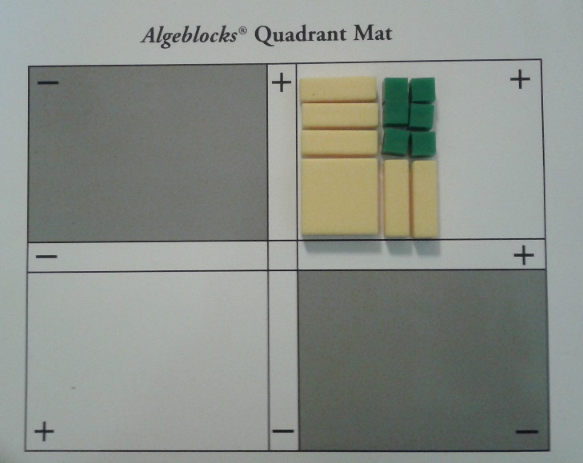
We have proven with Algeblocks that:
(x + 3)(x +2)= x² + 5x + 6

ACTIVITY 2: What would (x + -1)(-x -2) look like on the Algeblocks Quadrant mat? Using the Algeblocks place your equation in the appropriate factoring axis’. Your mat should look like this:

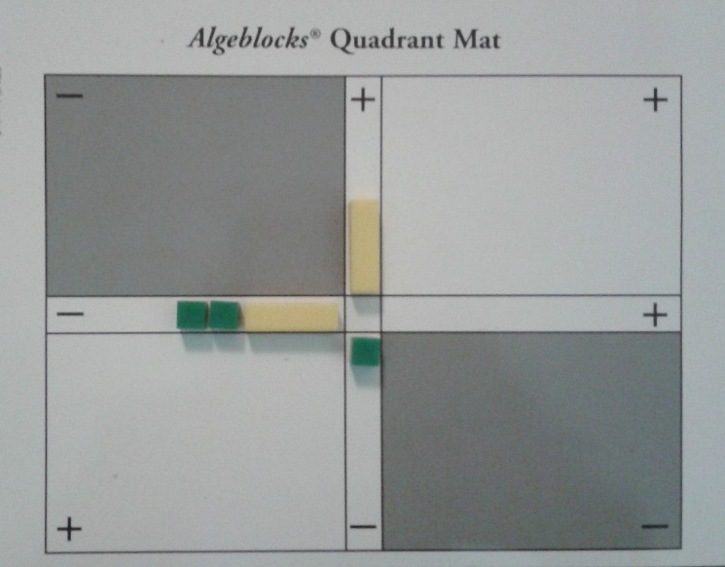
Note the positive and negative placement of your blocks.
X + -1 is on the vertical axis with the x positive and the unit negative.
-x -2 is on the negative horizontal axis.

Following the step by step process for Algeblocks, solve the equation.

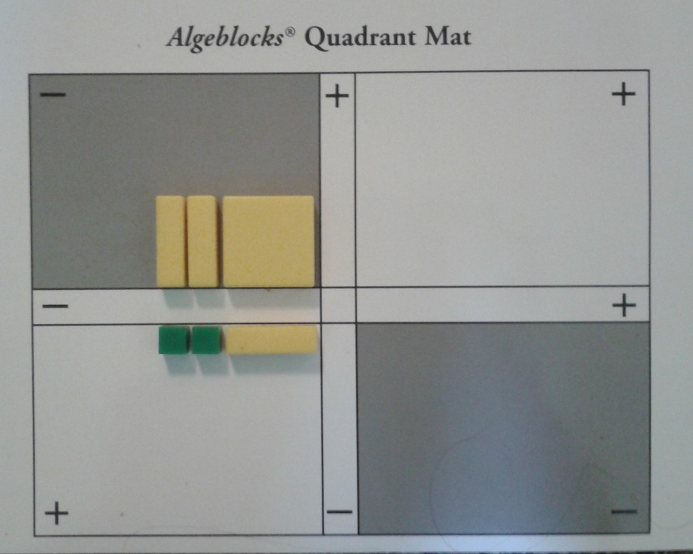
What do the Algeblocks show for the equation:
(x + -1)(-x -2)
We have one x² and 2x in the negative quadrant.
We have an x and two units in the positive quadrant.
-x² – x + 2
Can you see the square?

EXERCISE 1:
Solve the following equations with the Algeblocks. Write down your answers and draw a sketch of your finished Algeblock mat.

- (x – 3)(x + 6) 2. (-x + 7)(x + - 1) 3. (-x – 2)(-x + 4)

After assessing students with their basic use of Algeblocks, we would continue on to x⁴, xy and y^{2.}

References

Algebra Balance Scales - Negatives - NLVM. Utah State University, 1999-2017. Web. 22 July 2017. <http://nlvm.usu.edu/en/nav/frames_asid_324_g_3_t_2.html?open=instructions>.

"Algebra Lesson: Introduction to Algebra." Introduction to Algebra - Free Math Help. N.p., 06 June 2002. Web. 22 July 2017. <https://www.freemathhelp.com/introduction-to-algebra.html>.

"Distributive Property with Variables." PBS LearningMedia. N.p., n.d. Web. 22 July 2017. <https://tpt.pbslearningmedia.org/resource/mgbh.math.ns.distprop/distributive-property-with-variables/#>.

Ellis, Amanda G. "Variables." YouTube. YouTube, 23 Jan. 2013. Web. 22 July 2017. <https://www.youtube.com/watch?v=hK_LQaNDxi4>.

Holt, Rinehart, and Wilson. "Algebra Tools." Encyclopedia Britannica. Chicago, IL. 2006. page 7-8s.

"Introduction to Algebra." Math Is Fun. N.p., n.d. Web. 22 July 2017. <http://www.mathsisfun.com/algebra/introduction.html>.

Jellify, Jack N. "X Finds Out His Value." YouTube. YouTube, 31 Dec. 2008. Web. 22 July 2017. <https://www.youtube.com/watch?v=J2TYyUftI8k>.

Moore, Sara Delano. "Algeblocks - Quadrant Mat." YouTube. YouTube, 25 Nov. 2015. Web. 22 July 2017. <https://www.youtube.com/watch?v=G1NHdx6capE>.

Rivera, Ferdinand D. "Algeblocks Promote Algebraic Understanding." Hand2Mind. N.p., n.d. Web. 22 July 2017. <https://www.hand2mind.com/pdf/algeblocks/algeblocks-whitepaper.pdf>.

